# FIT 1047 ASSESSMENT 3

## Student name: Haoxuan Zhang

## Student ID: 34550720

Table of Contents

Background 3

Experiment 3

Result 4

Channel occupancy 4

Attenuation from different materials 4

Coverage 4

Measure the attenuation caused by body 4

Appendix 5

MAP 5

Screenshots of Measurement Data 6

# Background

This report Outlines the results of a WLAN field survey conducted at the Hargrave Andrew Library, Clayton Campus, Monash. The purpose of the experiment was to evaluate the performance of the wireless network and identify potential problems related to channel occupancy, signal attenuation, and overall coverage.

# Experiment

The survey used a WIFI-enabled laptop (mac) to scan wireless networks at different locations in the library and a mobile phone that could send hotspots. A total of four access points (APs) were identified. The measurements were carried out in eight different locations, ensuring coverage of at least 60 square meters. Record the following parameters for each AP (Figure 2 – Figure 9):

Network Name (SSID) ：大部分都是eduroam

MAC Address (BSSID)

Signal Strength (dBm) ：范围

Signal to noise ratio (SNR) ：

Supports 802.11 ：概括用了什么协议

Frequency band (2.4 or 5ghz)

Channel(s) used

A map of the survey area was drawn, indicating the location of ap and measuring points. (figure 1)

# Result

## Channel occupancy

The measurements show that two APs are running on overlapping channels, AP2 and AP3 on channel 36. This configuration may cause interference and affect the overall network performance. Aps can be reconfigured to run separately using non-overlapping channels.

查询思科路由器是否支持智能选择信道功能。如果可以，那就不用改，如果不可以，那就查询是否支持修改信道，然后修改对应WiFi信道即可

做一个插值测量，修改不同位置去定位路由器AP所在的位置

从接入点数量和评级上面去分析，如何优化

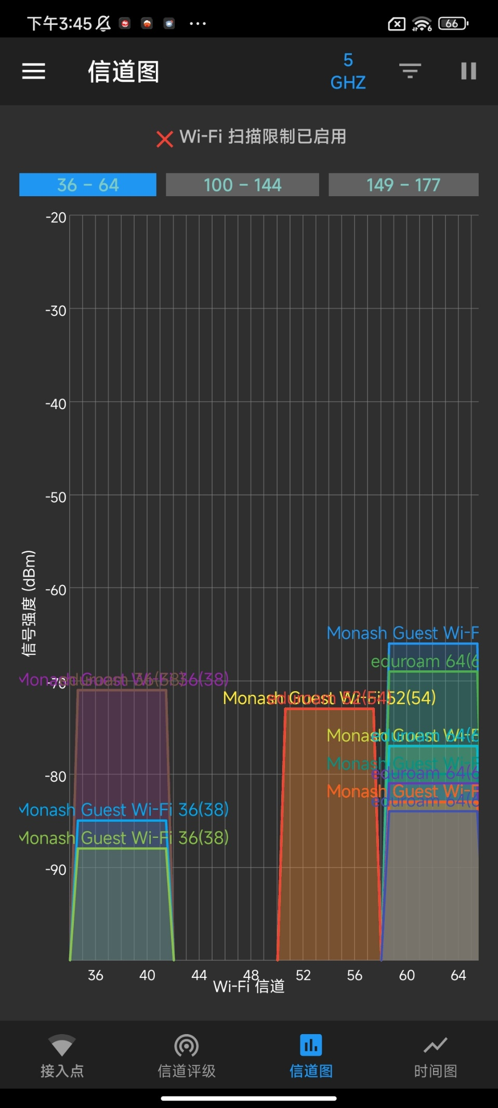

给出信道优化方案来，

1. 比较eduroam6 跟Monash lightboard control6 这两个WiFi信道占用，并且比较他们位置，作用范围。如果作用范围没有重叠太多，那就可以说明并且忽略。
2. 改进方案：移到44-48信道

## Attenuation from different materials

The signal strength measurement shows that the attenuation of the building material to the signal is obvious. For example, when measuring the strength of AP3, measuring position No. 3 and measuring position No. 8 have a glass wall in the middle. The glass wall blocking area (position 8) decreased by about 10 dBm compared to the open area (position 3) (see Figure 4 and Figure 9). In contrast, measuring position 6 and measuring position 7 measure the strength of AP4 with a concrete wall in the middle. The concrete wall blocking area (position 6) decreased by about 15 dBm compared to the open area (position 7) (see Figure 7 and Figure 8). This shows that the effect of not using materials on WIFI signal strength is also different.

加交叉引用

1. 注明为什么每次测量连接的WiFi自动变成5g，可能就是用了802.11什么协议，同时支持5g和2.4g，优先选择了5g

## Coverage

Coverage analysis shows that basically all parts of the country are fully serviced by WIFI, but overall speed can be improved because dBm is low even in open Spaces. Can also improve the configuration, such as using non-overlapping channels to improve dBm.

1、要测量5g和2.4gWiFi

2、测量WiFi的间断性，并且找到至少一个盲点（WiFi没有覆盖到的地方）

## Measure the attenuation caused by body

Using a mobile hotspot as an AP, the signal strength is -31dBm when the mobile hotspot is placed in an open area next to the measuring computer (without any occlusion). However, when the mobile hot spot is placed behind the body and the body is wrapped around the mobile hot spot, the signal strength is -50dBm. As a result, the human body significantly reduces WIFI signal strength. Because the human body is mainly composed of water and organic matter, water has a significant absorption effect on electromagnetic waves. (Figure 10 and Figure 11)

（可选）下载速度测量和干扰因素的判断，分析原因并且对技术细节做解释。

# Appendix

## MAP

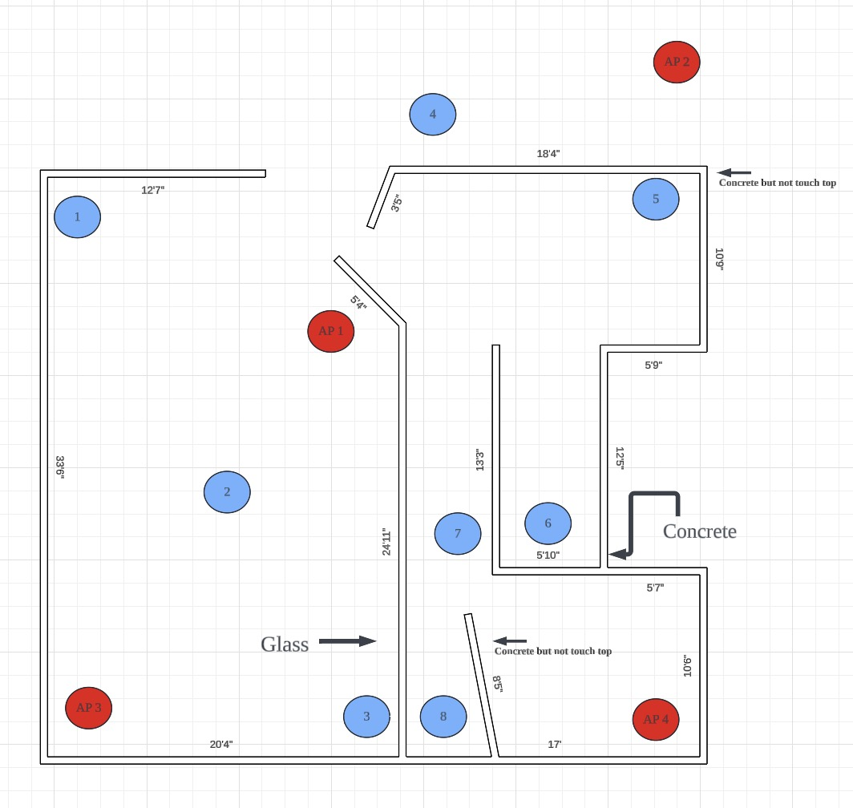

figure

需要标注AP的作用范围，画出圈圈，表示全覆盖或者有死角

Figure 1

## Screenshots of Measurement Data

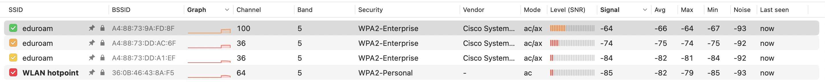

Figure 2

设计表格，突出展示SNR和signal在不同位置不同WiFi的值

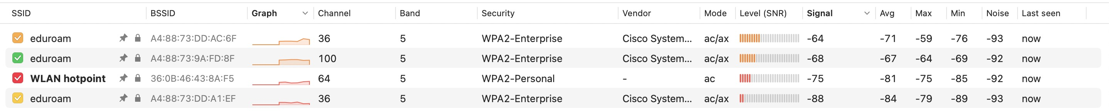

Figure 3

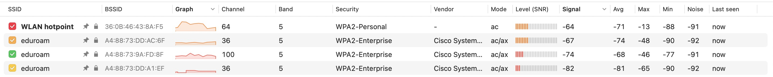

Figure 4

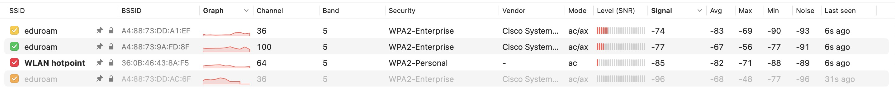

Figure 5

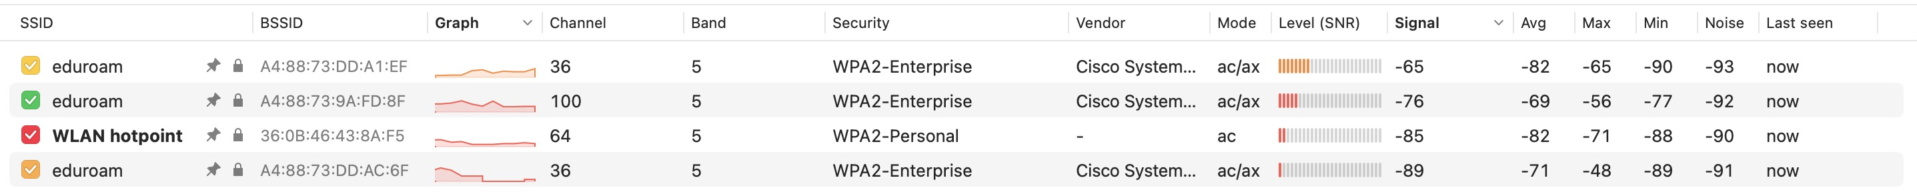

Figure 6

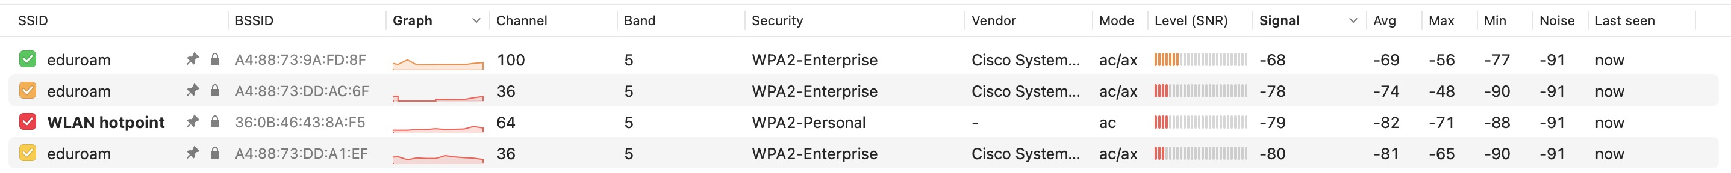

Figure 7

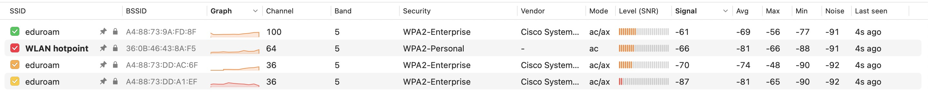

Figure 8

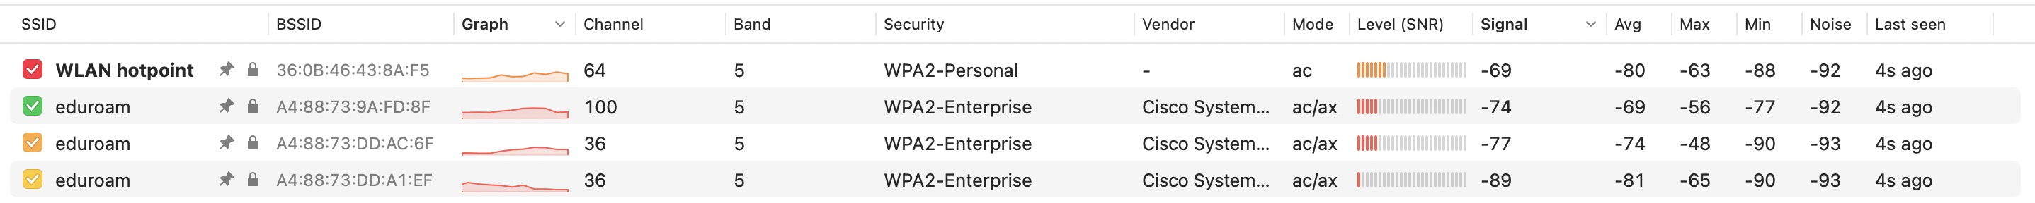

Figure 9



Figure 10



Figure 11